PHP (Hypertext Preprocessor)

This was used throughout the website, as the pages needed to read and insert into SQL databases of course this needed server side code in order to process. An example of a page would be GetItemInfo.php this is a page where the user can view the items information, this page has a few pieces of PHP and the rest is run from an Ajax call, but this page Loads in all the information about an item, this would usually be presented in in a way such as GetItemInfro.php?id=509 this tells the page to call the information related to the item with the ID of 509, in this case this item is a book “HANDBOOK OF EEG INTERPRETATION”. Other pieces of PHP on this page allows the user to select a date, this is done by using the PHP date function, it then uses a while statement, this is done to count days, and adding one day using date to string function in PHP, This was done so it did not need to be manually done by the user or a programmer adding new dates. As the server can write the days automatically, of course the website would have to trust that the Server Date and Time has been set correctly in order for this to work.

GetItemInfo.php also calls other pages in order to work, these being, CheckBookingDate.php and InsertLoan.php these are pages that are only called when they are needed by using JQuery

When using the page GetItemInfo.php and you select a day that you would want to book it will then use JavaScript to enable another select box where you can select how many days you would like to book it for, once this has been completed it will run a page called CheckBookingDate.php it uses ajax to send this info from the two select boxes, to run a script to check of the date chosen and the date that is should be returned is between anyone else’s booking, it does this by getting the day that is chosen and again using date to string to add the booking length to the booking day -1, it uses a -1 to count the day that the user books the item to allow them to return it the same day, as some items can only be booked for one day. Once this has been completed it will set information into hidden field that the user cannot see on the page. If the value is set to a specific value it will enable a booking button allowing them to book that item. If the item has already been booked out for the days booked, it will not enable the button and tell the user that it is not available for the days they have choose.

Once the user has a booking that they are able to book between days then they can press the book button, this runs code to create a booking after doing some checks, it first checks to see if the user is allowed to book that item, because currently every user can see every item, this allowing them to view and attempt to book items that they should not, of course this could be fixed at a later date if needed be, but for now the checks also occur when the user goes to book an item, this happens within the InsertLoan.php this page gathers the other required PHP files and runs them in a logical order, this being

getDateInfo.php

This is a page that gathers the date from the Selection fields this being the date that the user has chosen to book the item as well as the day that user will need to return said item this is a small PHP file that process this information

CheckLoan.php

This is code that runs to check if the user is able to book the item, here it checks if the user has a user type to which they are able to book said item, for example an item may only be bookable for Staff, and we don’t want students being able to book this. If the user then passes these checks it will then run another PHP from here to insert the loan to the database. This being:

InsertSQLLoan.php

This is the page that adds the first part of the loan this uses an SQL statement to do this, once this is done it then runs another PHP page called

SelectCurrentLoan.php

This is a page to select the most current loan from the user as we then need this information in order to run another PHP file that finishes adding the loan for the user. It gather information about the first part of the loan that has just been created, the most important thing being the Loan ID as this is needed in the next PHP file

InsertLoanContent.php

This is the page that adds to the rest of loan, this gets the information that is gathered from the previous file SelectCurrentLoan.php as it needed to gather the booking ID to add it the Loan Content.

GetBookingInfo.php

This is a simple page to get information about the booking to display it to the user later, as when the booking is a success we will give them a quick prompt to tell them this is information about their booking, it will also give SendConfirmEmail.php information that it can use to send an email

SendConfirmEmail.php

This is the page that sends an email to the User as well as the staff member who’s said item is being booked, this letting them know that it has been a success and gives them confirmation about their booking.

AddToCurrentLoans.php

The user should know how many items they have booked, this is a small PHP file that adds +1 to the current loans that the user currently has

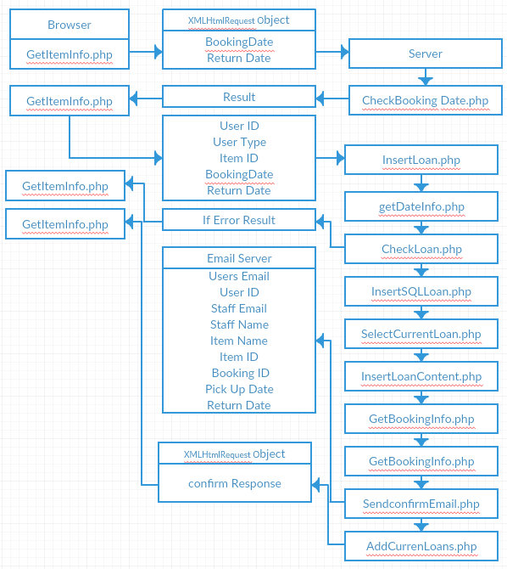

Html 5.0 (HyperText Markup Language)

CSS 3 (Cascading Style Sheets)

CSS was used to style the webpages, of course this also allowed us to make responsive web design thanks to the power of CSS 3 and HMTL 5.0 both of these together allowed the site to use a CSS command @media , this allows us to get the dimensions of the web page, this was used to make the site look better on mobile devices with smaller sized monitors. As style is important on a webpage as it helps the user navigate from one page to another with elements of the page being placed in easy to find places.

CSS also allowed the site to re-size the navigation bar for smaller screens as it turns in into a drop down menu rather than a list at the top of the screen. This taking up less space for the user whist they navigate through the website.

JQuery (JavaScript library’s)

JQuery are a set of JavaScript libraries that has been implemented and used to make writing JavaScript easier, as they are exactly the same, and has been designed to simplify html. For this project we used version 3.1.0 from google library [1] [2]. We have used JQuery everywhere on the website, as it handles many things, these being:

Navigation

JQuery was used on the navigation rather than using the normal <a href=””> this was used because of how the site works. Instead of going to a new page the page that we want to the user to go to is loaded into an element that is on the page, this means that effectively the entire website is on the same page, of course this has its own benefits, as this allows us to hide pass variables from the Address bar on the page, if the user cannot modify the address they can’t access something they should not be accessing, for example if we choose to hide catalogue items from certain users then they cannot modify the address bar to find items that they are not supposed to, of course this can also be done using PHP, but if the user does not have to option to do it then it stops them from even attempting to do that. [image 1] of course the user can still see the id of the item when looking in the developer tools when looking at the networking traffic [image 2] of course if the user is able to access a page for an item they are not supposed to book, they won’t be able to do it anyway because when booking the item it also checks the users Information before they are able to book it.

Loading Pages

Much like the navigation we load every page onto one page, this allows the page to feel like it is loading much faster. This works together with the navigation in order to display the pages and for pretty much the same reasons, this works by finding the element that the user has cocked on, and then loading into another element a page they corresponds to the element clicked. Below is an example of how the code works.

$(document).ready(function() {

$(".addi").click(function() {

$(".holder").show();

$(".holder").load("ajax/Pages/Inventory/add_inventoryImage.php");

}); });

Calling Ajax

We also use JQuery for calling AJAX and JQuery’s version of Ajax is much easier to use, it allowed us to gather the information from textboxes and selection boxes on the page and then set them in variables to be sent off to other pages, this allowed information to be transferred to other pages without having to be redirected.

Disabling/hiding and displaying elements

Of course using this allows the app to disable buttons and other items that are not needed or should not be used by the user at a certain time, there are a few examples of this, and one being on the administrative pages, and on these pages the website disables the textboxes and hides buttons that are not being used. When the edit button is pressed by the user it will enable the textboxes that are relevant to the one that is pressed, it will also display the save and cancel buttons as they would only be needed once they original edit button has been pressed, this is used as the website does not need to show elements and objects to the user that they don’t currently needed to edit.

Changing and creating ID’s and classes on HTML elements

This also works in conjunction with hiding and displaying elements. This allows the website to know what element needs what attributes, as if each element had the same attribute it can cause problems scenically when using ID’s as an ID can only be used once on the page. The website has been made to set the ID Attribute to an element only when it needs it, this allows the website to only collect the correct information.

AJAX (asynchronous JavaScript and XML)

Ajax is not a programming language, but rather a combination of JavaScript HTML, it uses browser built-in XMLHTMLREQUEST to request data from the webserver, this allows the site to enter information into the database aswell as gather information to the database, although AJAX is mostly used for XML we can also use it to call a PHP file which is just as fine as the page can see the gathered information in variables and send it as normal to a PHP file. 

This works in 6 steps: [3]

1: an event occurs on the webpage, such as a click event, or a change event, usually on the webpage it would most likely be a click event, once this happens the information is gathered into;

2: An XMLHTMLREQUEST object, this would be created by JavaScript this is the information that the website creates in order for it to send the results to a PHP file, once this information has been gathered it will;

3: Send the XMLHTMLREQUEST to the web server, the data that has been sent will then;

4: be processed by the server, in the case of BookIT it will use the variables that we have given the PHP file and do handle a request with it, sometimes it will check all the dates of an item that has been booked in the database, and then check the date that we have sent to it, if an item has or not been booked for the days chosen it will send a response back

5: The response is sent back to the webpage, using Ajax means that the site does not need to navigate between pages, it allows the page to send information to another pages whilst allowing the user to stay where they are.

6: the response is read by the JavaScript, here the JavaScript decides what to do with it, it has been programmed to display this information that has been returned to it, carrying on with the date example it can disabled an enable a button on the webpage, this being the button that allows the user to book the item or not

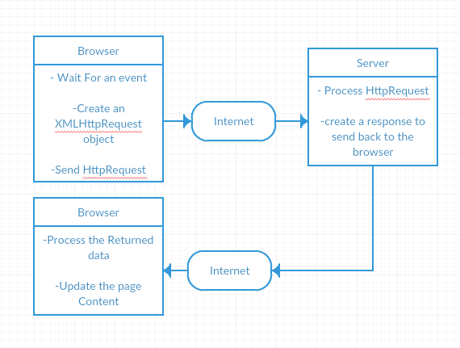

Ajax used on the site as this allowed the pages to move data from one page to another, used all over the website this was extremely helpful, especially on the page where we had to check if the user can book the item, when they selected two dates from the select boxes it would send them to the script that would check if the dates that the user imputed where available for them to book, if we done this with normal PHP they would then be redirected to another page or just have an error when they tried to book an item that has already been booked for them days, but as we could send this information and get a result back it made it easier for the user to navigate and see if they could book things or not.

Ajax is a good way to cut loading times, the site only needs to load particular data when it's needed, using ajax means that we don't use large amount of data, as the site does not need to load an entire page of code that does many things, as the information called to the page when it's needed and not it being loaded to the page without it being needed.

MySql (databases)

Mysql was used to

# Bibliography

|  |  |
| --- | --- |
| [1] | "Google Hosted Libraries," Google, 17 January 2017. [Online]. Available: https://developers.google.com/speed/libraries/. [Accessed 2016]. |
| [2] | "Jquery," Jquery, [Online]. Available: https://jquery.com/. |
| [3] | w3schools, "w3schools," w3schools, [Online]. Available: https://www.w3schools.com/xml/ajax_intro.asp. |

Appendix

Image #1

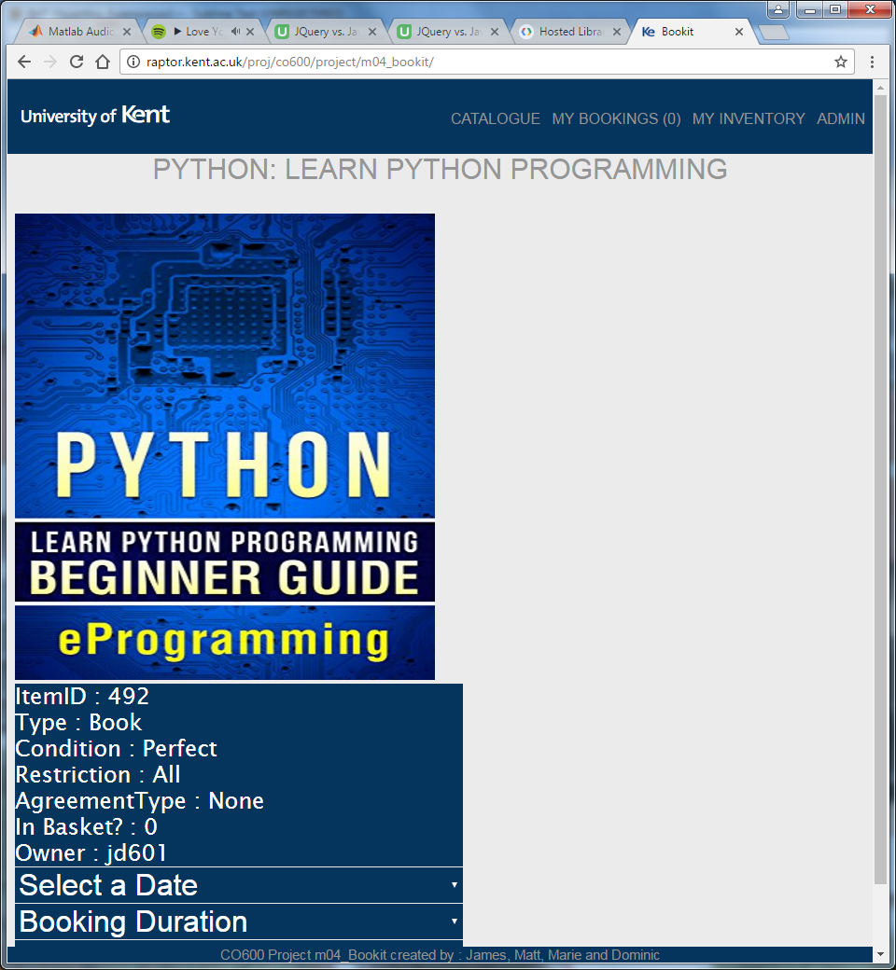

Image 2

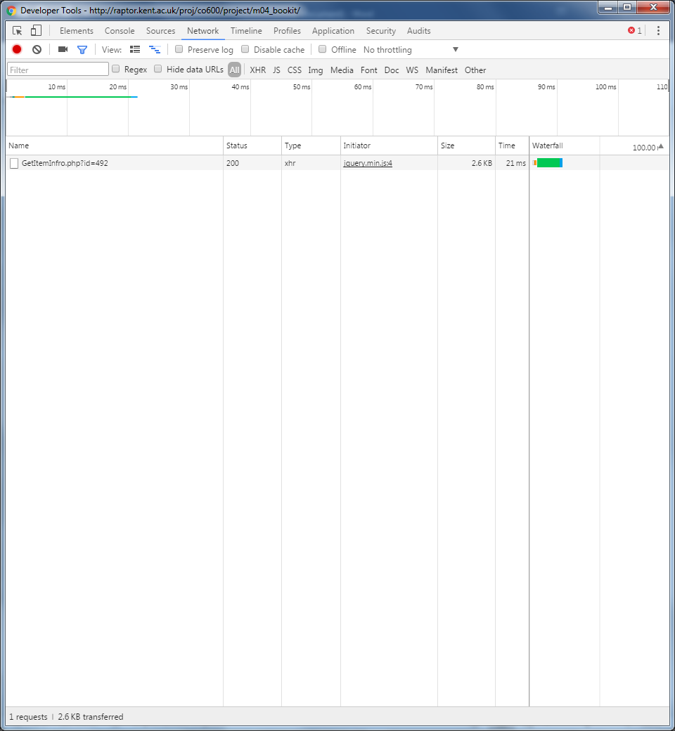

Image 3

